***Chapter 10 – Acids and Bases***

Outline

**Ionization of Water**

**Ions** – tiny charged molecules in water

**Ionization** – The process of forming ions in water

When water ionizes both hydrogen (H+) and hydroxide (OH-) ions are produced.

**Hydrogen ions** are hydrogen atoms that are **positively** charged.

**Hydroxide ions** are one oxygen atom bonded to one hydrogen atom and have a **negative** charge.

**Pure water** – equal number of hydrogen and hydroxide ions, so it is neutral

**Acids**- release hydrogen ions into water solutions

**Strong Acids** – ionize completely when dissolved in water (**all** acid the molecules break apart and release **hydrogen** ions into the solution)

**Weak Acids** – only a **small percentage** of molecules ionize and the rest remain neutral.

**Bases**- release hydroxide ions into water solutions

**Strong Bases** – ionize completely when dissolved in water (**all** bases molecules break apart and release **hydroxide** ions into the solution)

**Properties of Acids and Bases**

**Acids Bases**

Sour bitter

Change color of some foods/plants milk of magnesia

Feels slippery

**The pH Scale**

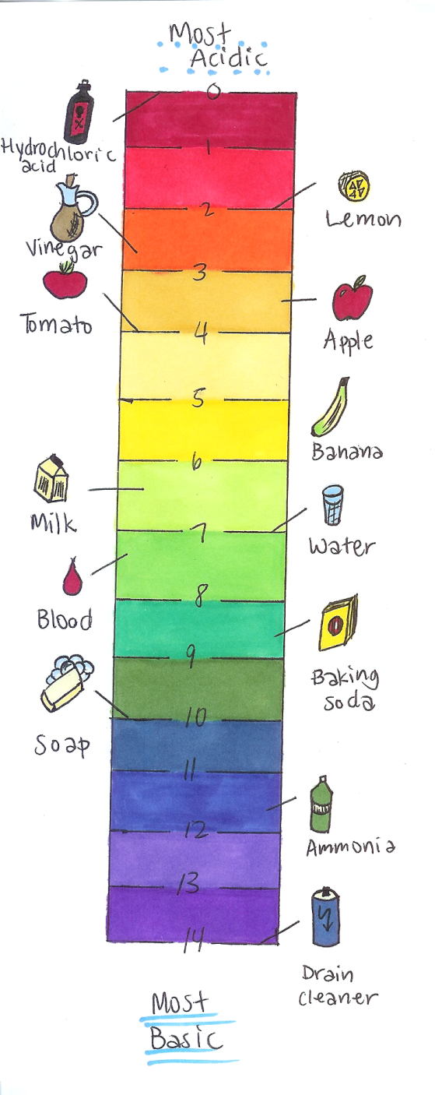**pH Scale** – a mathematical scale in which the concentration of hydrogen ions in a solution is expressed as a number from 0-14

**indicator –** a substance that changes color depending on the pH

**concentration** – measure of the amount of a

substance in a given unit of volume

**molarity** – number of moles of solute per liter of solution

**titration** – method used to determine the concentration of

an acid or base